* While analysing payal’s json data. I got below scenario to do the thing to practice more efficiently
* Scenario – 1 details:
  + This scenario need to complete first
  + I will create a simple employee object with following field
    - Employee Id
    - Name
    - Position
    - Salary
  + Make web service code where if external system hit with particular employee Id then I will share all the details with them and send all json data to them
  + I will make another code where I will consume all the data by hitting this particular endpoint and save the record in my system objects.(both the system can be a Salesforce system)
  + Use following json to end from system and consume in another system

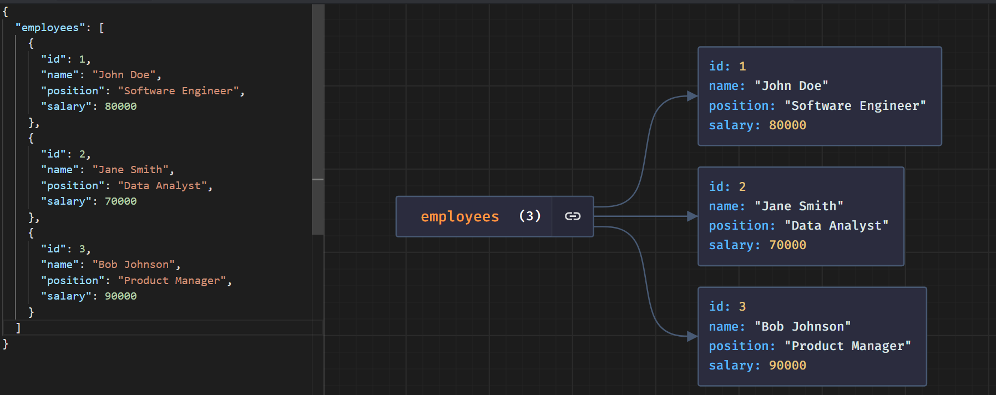

* Integrated two system:
  + System A - [pankajkumardev@psl.com](mailto:pankajkumardev@psl.com) (web service code here – acting as source org)
  + System B - [pankajvitmca@pd1.com](mailto:pankajvitmca@pd1.com) (consuming data of system A – acting as data consumer)
* Scenario – 2 details:
  + Create one object employee and create following fields like below
    - Full name
    - Gender
    - Birth year
    - Birthd date
    - linkedIn URL
    - facebook URL
    - twitter URL
    - github URL
    - work email
    - personal email
    - mobile number
    - job title
    - Job company
    - Job company website
  + Create another object “experience” and associate with employee Id and create record for every experience. You can create following field inside it
    - Employee Id
    - Company Name
    - Start data
    - End date
    - Company website
    - Company location
  + Create another object “education” and associate with employee Id and create record for every education details. You can create following field inside it
    - Employee Id
    - Degree name
    - College/school name
    - Location
    - Start date
    - End date
    - GPA
  + Make web service code where if external system hit with particular employee Id then I will share all the details with them and send all json data to them
  + I will make another code where I will consume all the data by hitting this particular endpoint and save the record in my system objects.(both the system can be a Salesforce system)
  + Use payal shared JSON for visualizing such type of scenario